https://goec-main.vercel.app/

- Add Favicon

- Lead form here (red box)
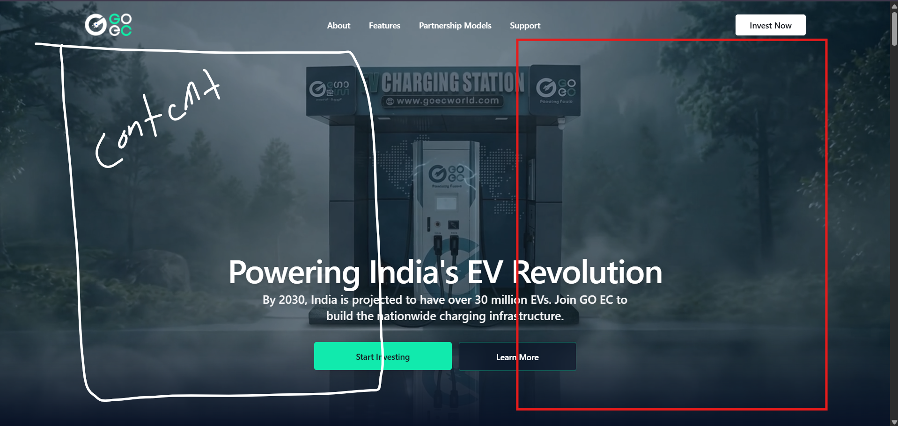
Lead for submit or next button need different or this same vibrant mint green

Reference
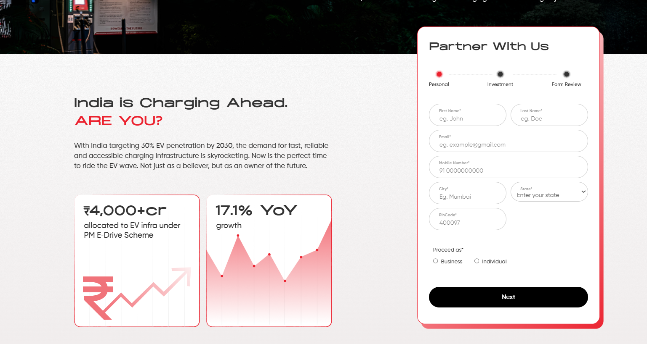

Need to add trust building factors in the header or near to the bottom


Need to change the current style, digits look small. If we can add the revenue, % increased or something related to that will help more.

- Time taking for lead submission

- Basic details first
(Kerala and Karnataka investment amount and model is different)

Name
Phone number
Mail
City
State (if they are entering kerala 35L form need to open or they enter state Karnataka 50L - 55L form need to open)

In the current form user enter No to this question Our investment plan starts from ₹35 lakhs. Are you interested in proceeding? The form allows that user to the next questions. If they submit No then the form needs to close with a thank you message.

Lead flow
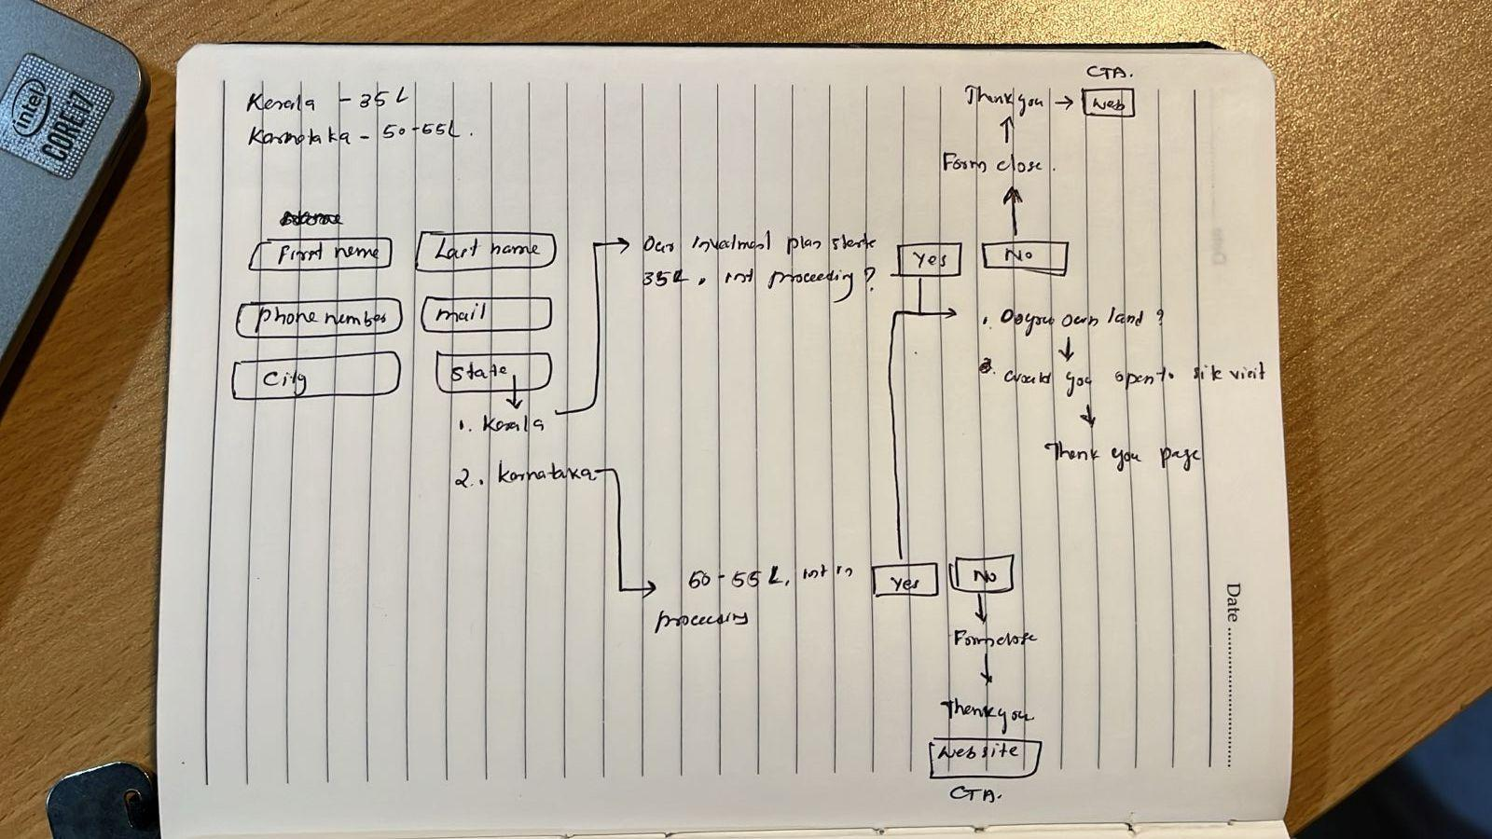

Remove 35L from here and while clicking Apply Now, redirect to new form
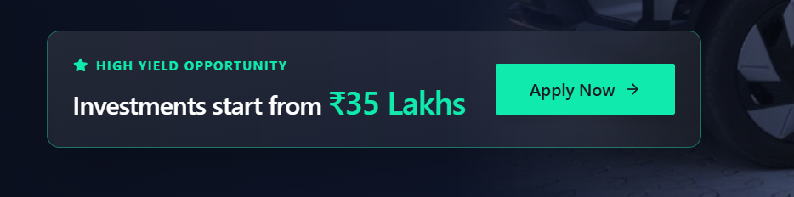

Add I COCO
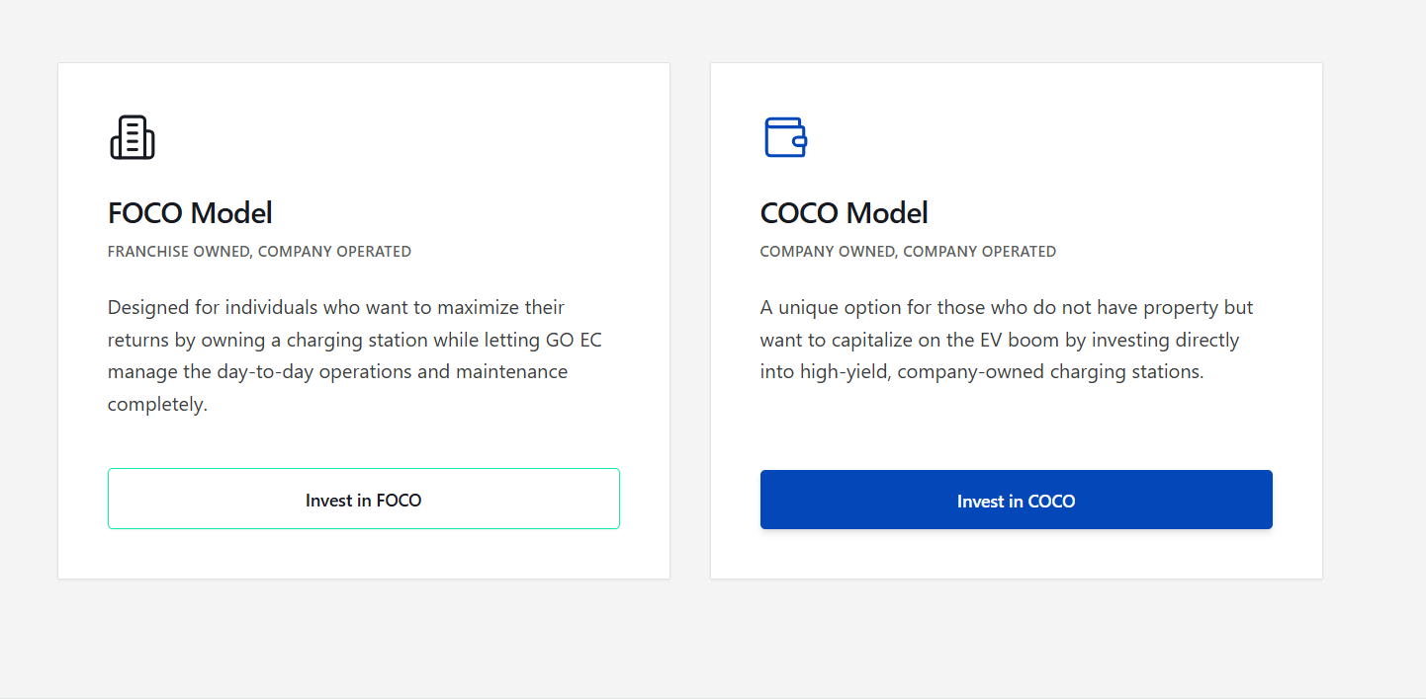

Users can visit youtube from here (remove all Outbound links from the landing page)
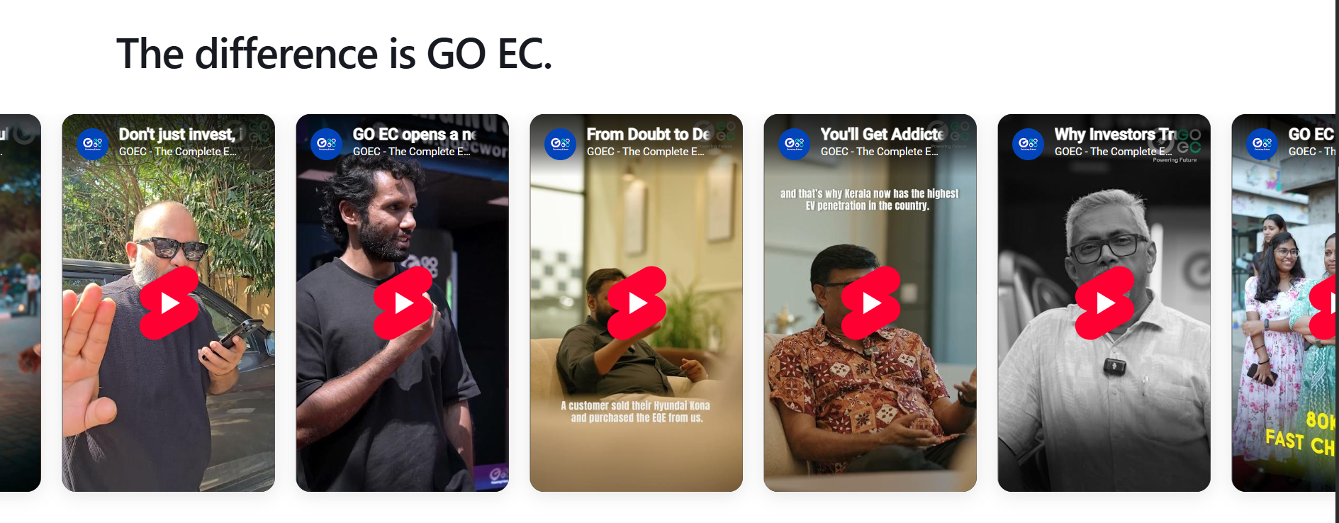

Frequently Asked Questions (kerala and karnata investment is different)
